Task No: 11 A Date:24/10/25 | Collect Social Media Data from a Twitter to a Local File with the Topic ‘covid 19’  Tools: Python: Tweepy, Twitter Developer | CO5 K3
AIM:
To collect Social Media Data from a Twitter to a Local File with the Topic ‘covid 19’

PROCEDURE:
- Install tweepy and json module in pycharm
- Import tweepy and json module.
- Create an account in Twitter Developer mode.
- Get the Twitter API credentials – consumer key, consumer secret, access token, access token secret.
- Authenticate with Twitter API
- Search query and set, number of tweets to collect
- Create File to save the collected data with file name 'covid19_tweets.json'
- Collect tweets and save to a file

PROGRAM:
import tweepy import json

consumer_key = 'KbKxl06BkeqAcwNhJnBMN5s5M'
consumer_secret = 'LaVFLQhzzy57mVDo9dbT60QOXnN6Ajm09Q6PAmSgPGoozZqhM9' access_token = '1709726896194244609-w4KYxcGTyA4GHjlO7kJHzQlCWiVvSm' access_token_secret = 'G8uyaHaIXoDUmFzVW3Ao6sAWRZ328Y2B6RraAeEU8p4e3'

auth = tweepy.OAuth2BearerHandler(consumer_key, consumer_secret) auth.set_access_token(access_token, access_token_secret)
api = tweepy.API(auth, wait_on_rate_limit=True) search_query = 'covid 19'
num_tweets = 1000
output_file = 'covid19_tweets.json' tweets = []
for tweet in tweepy.Cursor(api.search, q=search_query, lang='en').items(num_tweets): tweets.append(tweet._json)

with open(output_file, 'w', encoding='utf-8') as file: json.dump(tweets, file, ensure_ascii=False, indent=4)

print(f'{len(tweets)} tweets collected and saved to {output_file}')

SAMPLE OUTPUT: 'covid19_tweets.json'
[{
"State": "Andaman and Nicobar Islands", "Confirmed": 7651,
"Recovered": 7518,
"Deaths": 129,
"Active": 4,
"Last_Updated_Time": "13/08/2021 23:27:22",
"Migrated_Other": 0, "State_code": "AN", "Delta_Confirmed": 0,
"Delta_Recovered": 0,
"Delta_Deaths": 0, "State_Notes": ""
},
{
"State": "Andhra Pradesh", "Confirmed": 2066450,
"Recovered": 2047722,
"Deaths": 14373,
"Active": 4355,
"Last_Updated_Time": "13/08/2021 23:27:22",
"Migrated_Other": 0, "State_code": "AP", "Delta_Confirmed": 0,
"Delta_Recovered": 0,
"Delta_Deaths": 0, "State_Notes": ""
}]

RESULT:
Thus, to collect Social Media Data from a Twitter to a Local File with the Topic ‘covid 19’ using python were successfully completed.

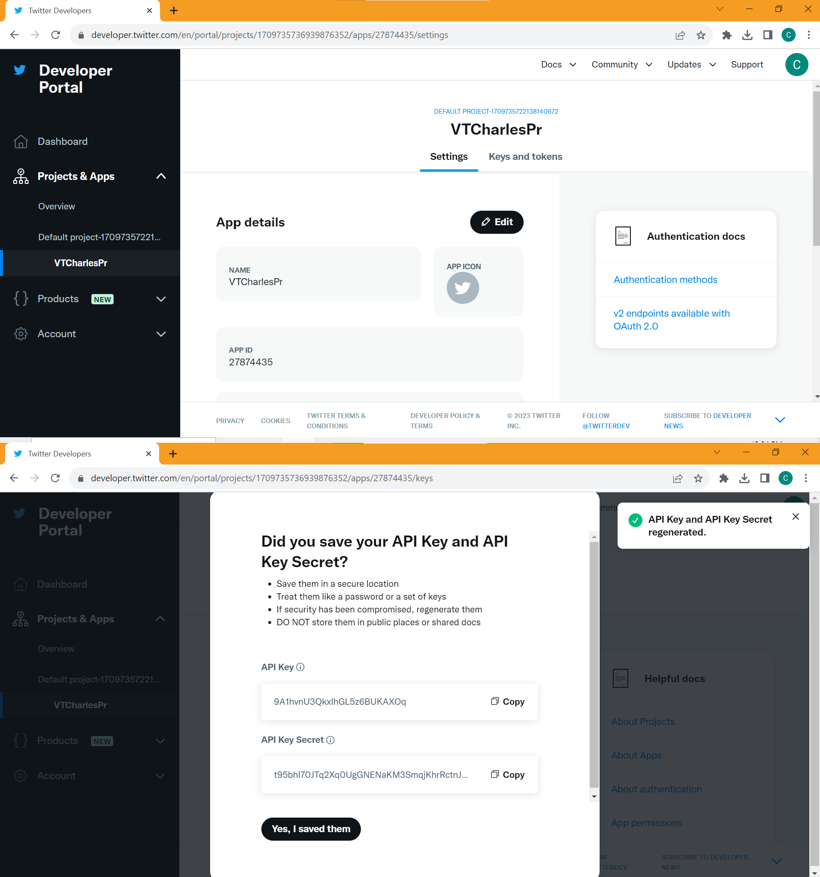

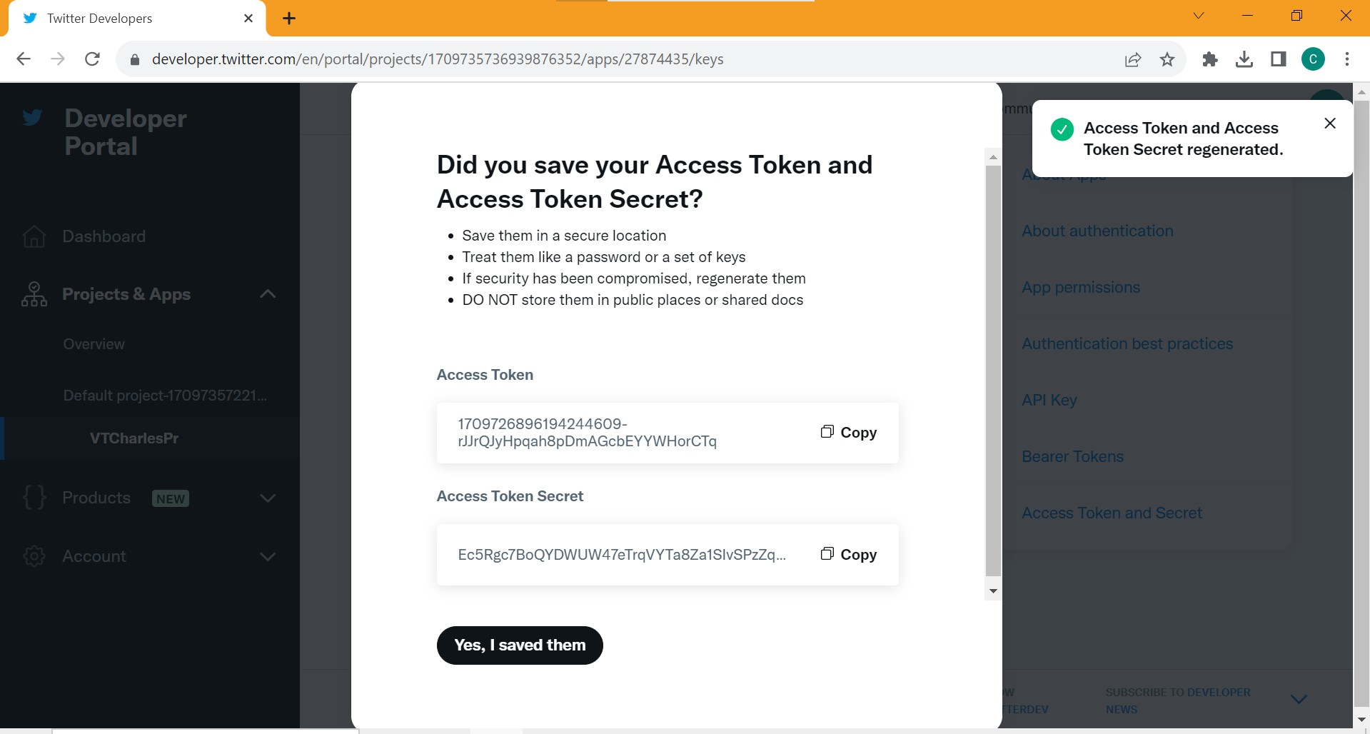
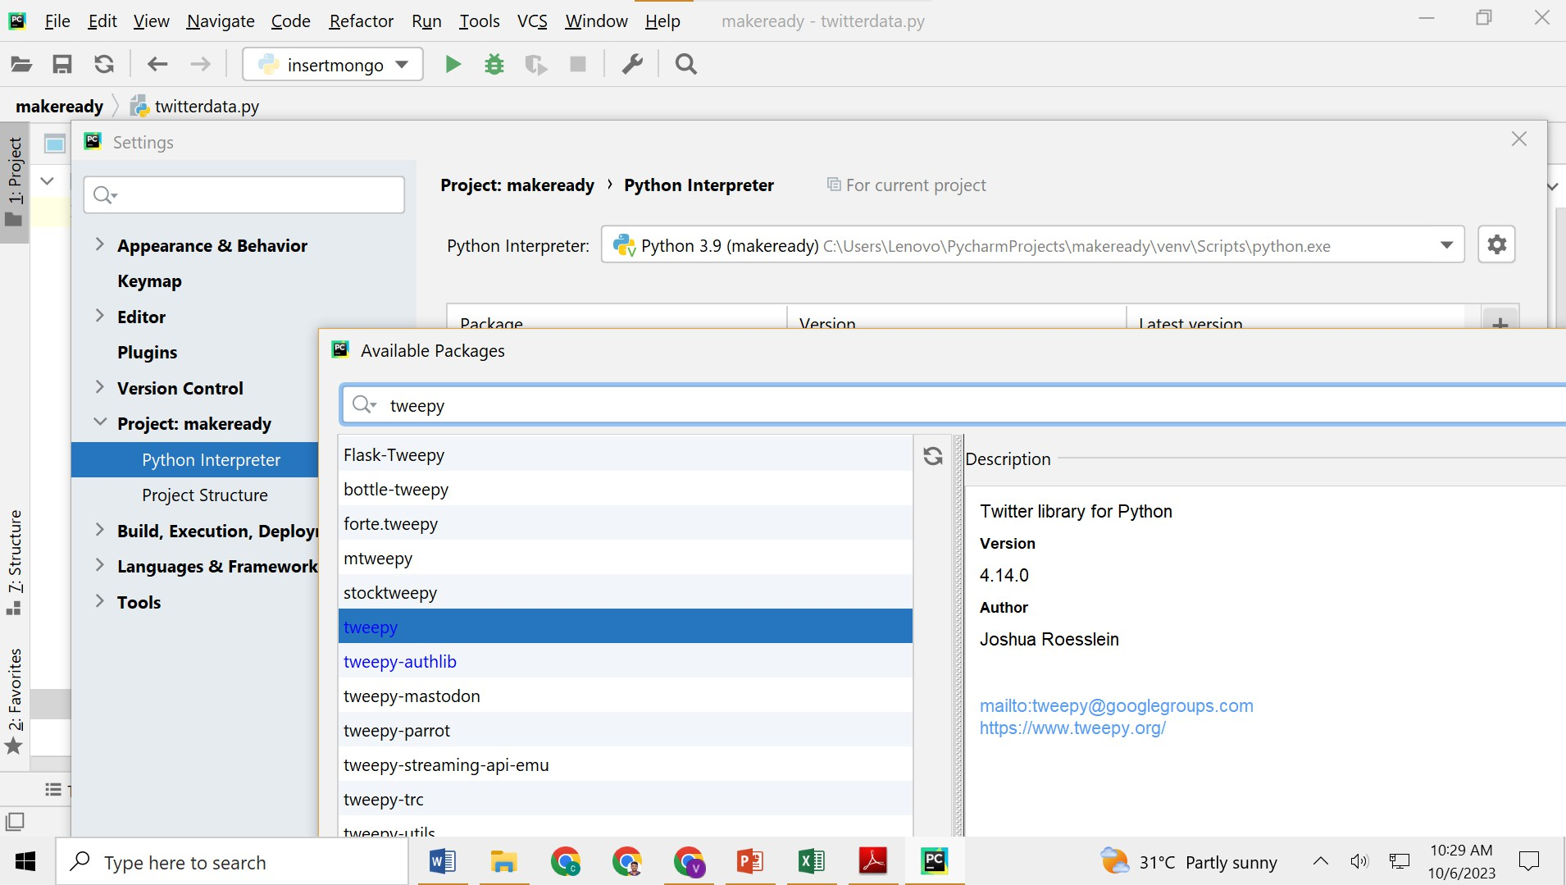

Task No: 11 B  Date: | Download and Set Up MongoDB Server and a Client Mongodb Compass.  Tools: MongoDB, Python: Scipy | CO5  K3
AIM:
To download, configure and upload the COVID19 datasets using MongoDB Server and a Client Mongodb Compass.
PROCEDURE:
- Installing MongoDB on Windows:
- Go to the official MongoDB website (https://www.mongodb.com/try/download/community) and download the MongoDB Community Server for Windows.
- Run the downloaded installer (.msi file).
- Choose a custom installation if you want to specify a custom installation directory or options.
- After installation, MongoDB should start automatically as a Windows service. Check this in the Windows Services Manager.
- Open Mongodb Compass, By default, MongoDB listens on port 27017.
- Import the COIVD19, state-wise data into the Mongodb
SAMPLE INPUT FILE: [File Name: covid19statewise.json]
[{
"State": "Andaman and Nicobar Islands", "Confirmed": 7651,
"Recovered": 7518,
"Deaths": 129,
"Active": 4,
"Last_Updated_Time": "13/08/2021 23:27:22",
"Migrated_Other": 0, "State_code": "AN", "Delta_Confirmed": 0,
"Delta_Recovered": 0,
"Delta_Deaths": 0, "State_Notes": ""
},
{
"State": "Andhra Pradesh", "Confirmed": 2066450,
"Recovered": 2047722,
"Deaths": 14373,
"Active": 4355,
"Last_Updated_Time": "13/08/2021 23:27:22",
"Migrated_Other": 0, "State_code": "AP", "Delta_Confirmed": 0,
"Delta_Recovered": 0,
"Delta_Deaths": 0, "State_Notes": ""
}]
OUTPUT:
Import Completed

38 Documents Imported.

RESULT:
Thus the MongoDB Server and a Client Mongodb Compass were download, configured and COVID19 datasets were imported into Mongodb.
